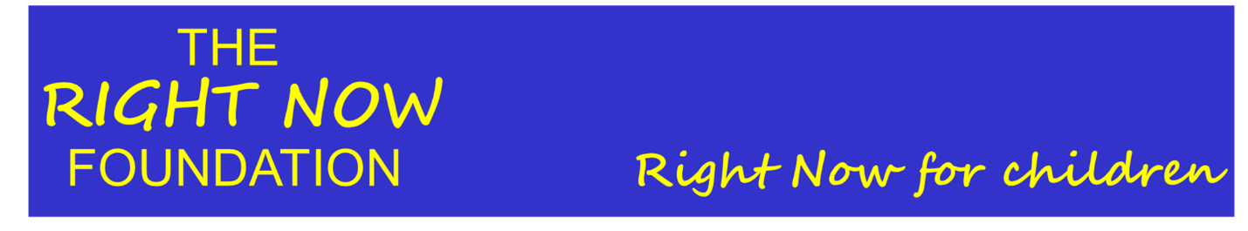

Data Protection Policy

Last updated | 17.05.18

Definitions
Charity | means Right Now Foundation, a registered charity.
GDPR | means the General Data Protection Regulation.
Responsible Person | means Jenny Harris Chief Executive Officer
Register of Systems | means a register of all systems or contexts in which personal data is processed by the Charity.

1. Data protection principles
The Charity is committed to processing data in accordance with its responsibilities under the GDPR.
Article 5 of the GDPR requires that personal data shall be:
- processed lawfully, fairly and in a transparent manner in relation to individuals;
- collected for specified, explicit and legitimate purposes and not further processed in a manner that is incompatible with those purposes; further processing for archiving purposes in the public interest, scientific or historical research purposes or statistical purposes shall not be considered to be incompatible with the initial purposes;
- adequate, relevant and limited to what is necessary in relation to the purposes for which they are processed;
- accurate and, where necessary, kept up to date; every reasonable step must be taken to ensure that personal data that are inaccurate, having regard to the purposes for which they are processed, are erased or rectified without delay;
- kept in a form which permits identification of data subjects for no longer than is necessary for the purposes for which the personal data are processed; personal data may be stored for longer periods insofar as the personal data will be processed solely for archiving purposes in the public interest, scientific or historical research purposes or statistical purposes subject to implementation of the appropriate technical and organisational measures required by the GDPR in order to safeguard the rights and freedoms of individuals; and
- processed in a manner that ensures appropriate security of the personal data, including protection against unauthorised or unlawful processing and against accidental loss, destruction or damage, using appropriate technical or organisational measures.”

2. General provisions
- This policy applies to all personal data processed by the Charity.
- The Responsible Person is responsible for data protection by the Charity and shall take responsibility for the Charity’s ongoing compliance with this policy.
- This policy shall be reviewed at least annually.
- The Charity shall register with the Information Commissioner’s Office as an organisation that processes personal data.

3. Lawful, fair and transparent processing
- To ensure its processing of data is lawful, fair and transparent, the Charity shall maintain a Register of Systems which will detail the reason and protection for data.
- The Register of Systems shall be reviewed at least annually.
- The charity operates in India through partner organisations, and as such will comply with national Indian data regulations, however the charity has decided as its organisation and central administration is run from the UK that the lead data protection authority will be the UK. This is the authority that the charity contacts for compliance activity such as registering a data protection officer, notifying a risky processing activity or notifying a data security breach.
- Individuals have the right to access their personal data and any such requests made to the charity shall be dealt with in a timely manner within the 30 day limit. Our policy for subject access requests states that the 30 days starts from the day the charity receives the identifying information required and the information request. If we require additional information to help find an individuals’ data we will ask for it. We will wait until we have all the necessary information before dealing with the request. The Charity will try to provide the information in writing, proving a copy of the information in permanent form; an explanation of any technical or complicated terms; any information about where the information is from; a description of the information, the purposes for processing the information and who the organisation is sharing the information with. Sometime we cannot share information, such as when the information you have asked for contains information that relates to another person.

4. Lawful purposes
- All data processed by the charity must be done on one of the following lawful bases: consent, contract, legal obligation, vital interests, public task or legitimate interests.
- The Charity shall note the appropriate lawful basis in the Register of Systems.
- Where consent is relied upon as a lawful basis for processing data, evidence of opt-in consent shall be kept with the personal data. It will be clear who consent is being given to, consents will be actively given and requests will be ‘unbundled’.
- Consent as a lawful basis for processing data is relevant for fundraising and marketing activity. Consent is not appropriate in the case of children’s data as children can not meaningfully give their consent. In some case’s parental or guardian consent may be obtained but due to the nature of the beneficiaries this is not always appropriate or realistic.
- Where communications are sent to individuals based on their consent, the option for the individual to revoke their consent will be clearly available and systems will be in place to ensure such revocation is reflected accurately in the Charity’s systems.

5. Data minimisation
- The Charity shall ensure that personal data are adequate, relevant and limited to what is necessary in relation to the purposes for which they are processed.
- The Charity operates in India through partner organisations. The government of India requires partners to share personal data on the Child Welfare website, partners comply with this although have no influence over the security of that data once entered on those government systems.

6. Accuracy
- The Charity shall take reasonable steps to ensure personal data is accurate.
- Where necessary for the lawful basis on which data is processed, steps shall be put in place to ensure that personal data is kept up to date.

7. Archiving / removal
- To ensure that personal data is kept for no longer than necessary, the Charity shall put in place an archiving policy for each area in which personal data is processed and review this process annually.
- The archiving policy shall consider what data should/must be retained, for how long, and why.

8. Security
- The Charity shall ensure that personal data is stored securely using modern software that is kept-up-to-date.
- Access to personal data shall be limited to personnel who need access and appropriate security should be in place to avoid unauthorised sharing of information.
- The Charity works with partner organisations in India, who in collecting and processing the data operate as data processors to the charity as data controller. As such we require our partners to securely collect and process this data, details of which are recorded in the Register of Systems.
- When personal data is deleted this should be done safely such that the data is irrecoverable.
- Appropriate back-up and disaster recovery solutions shall be in place.

9. Breach
In the event of a breach of security leading to the accidental or unlawful destruction, loss, alteration, unauthorised disclosure of, or access to, personal data, the Charity shall promptly assess the risk to people’s rights and freedoms and if appropriate report this breach to the ICO.

